Gemini School of Dance

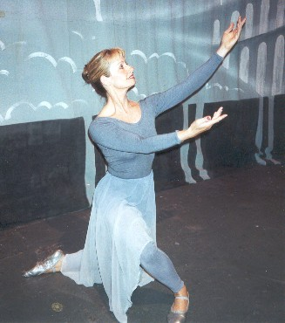
Order Form

Jacqui Everson
01495 756567
www.geminischoolofdance.co.uk

Please complete the form below for the items you wish to order. A list of available items and prices can be found on the web site.

Order placed by:

Address:

Telephone Number:

E-mail address:

Date order placed:

Item  Description | Size | Amount | Total
 |  |  | £
 |  |  | £
 |  |  | £
 |  |  | £
 |  |  | £
 |  |  | £
 |  |  | £

Total Amount: £________

Please hand the order form with payment to Jacqui or send to the above address.

Please make cheques payable to J Everson.

